CREATE TABLE EMPLOY(EMP_ID NUMBER,EMP_NAME VARCHAR(20),DESIGNATION VARCHAR(20),SALARY NUMBER);

INSERT INTO EMPLOY VALUES(11026,'Jagan','Software Engineer',90000);

INSERT INTO EMPLOY VALUES(11036, 'Smith', 'Data Scientist', 120000);

INSERT INTO EMPLOY VALUES(11046, 'Johnson', 'Marketing Manager', 110000);

SELECT*FROM EMPLOY;

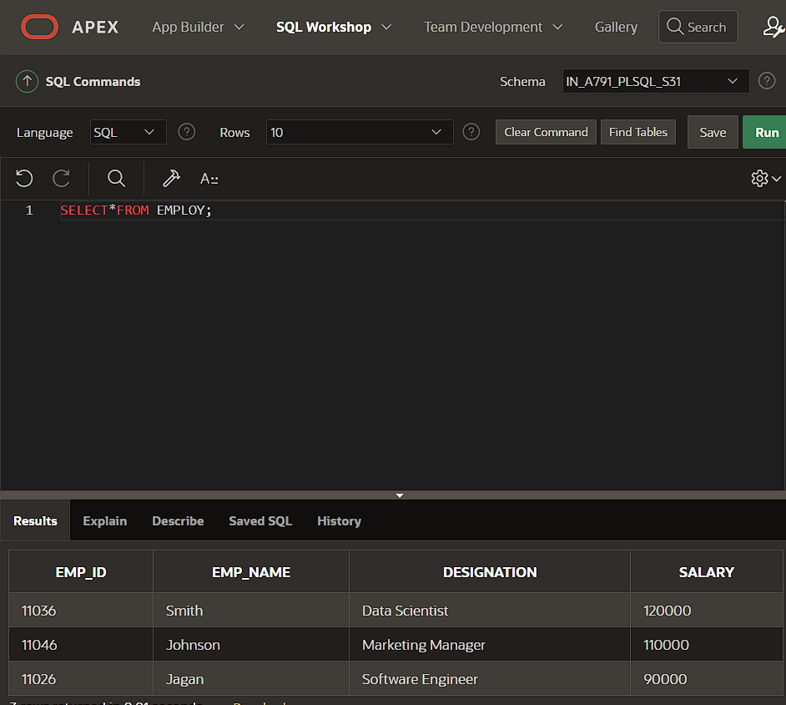

UPDATE EMPLOY SET SALARY=95000.00 WHERE SALARY=90000;

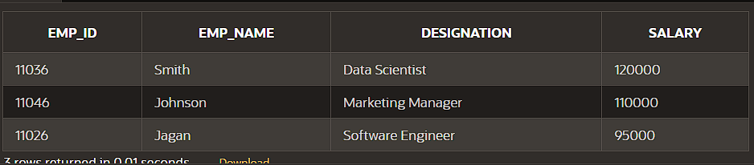

DELETE FROM EMPLOY WHERE EMP_ID=11046;

SELECT*FROM EMPLOY;

